* **Working with EditTextView to connecting the internet.**

**Xml file:**

* **SimpleTextView:**

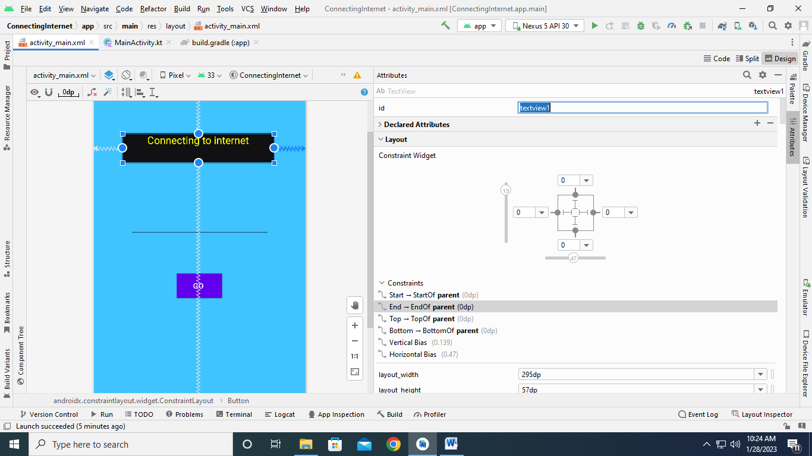 **EditTextView :**

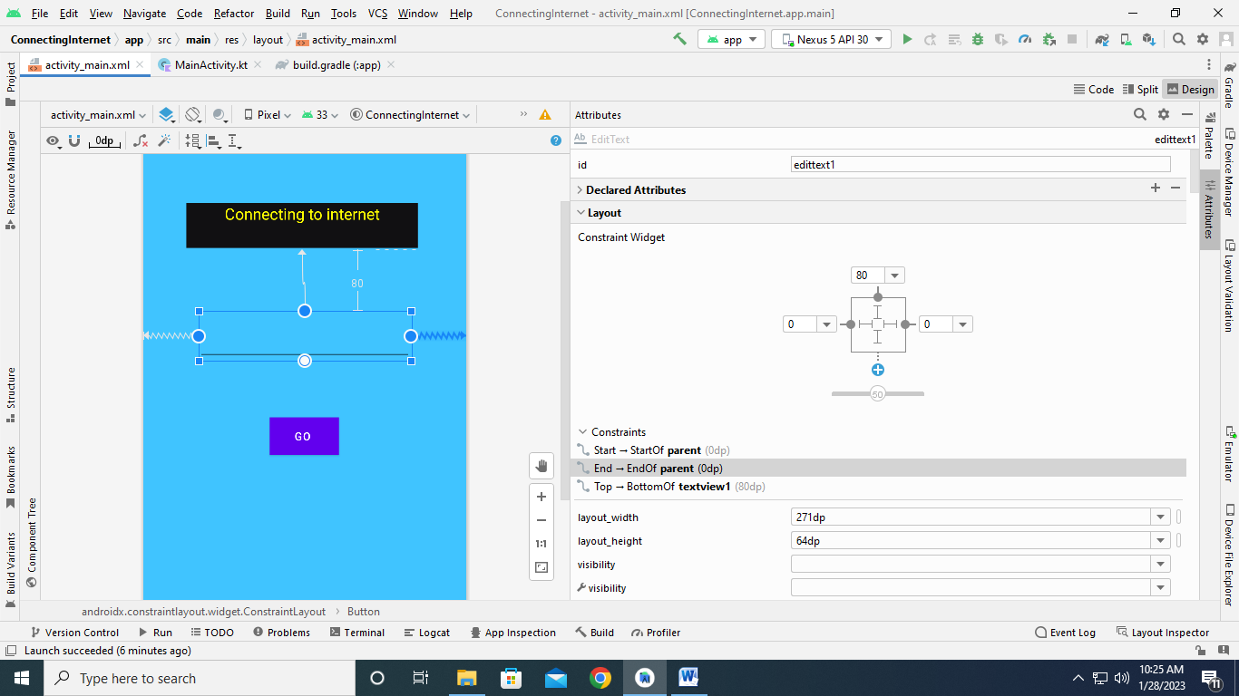

* **Button for go to browser window:**

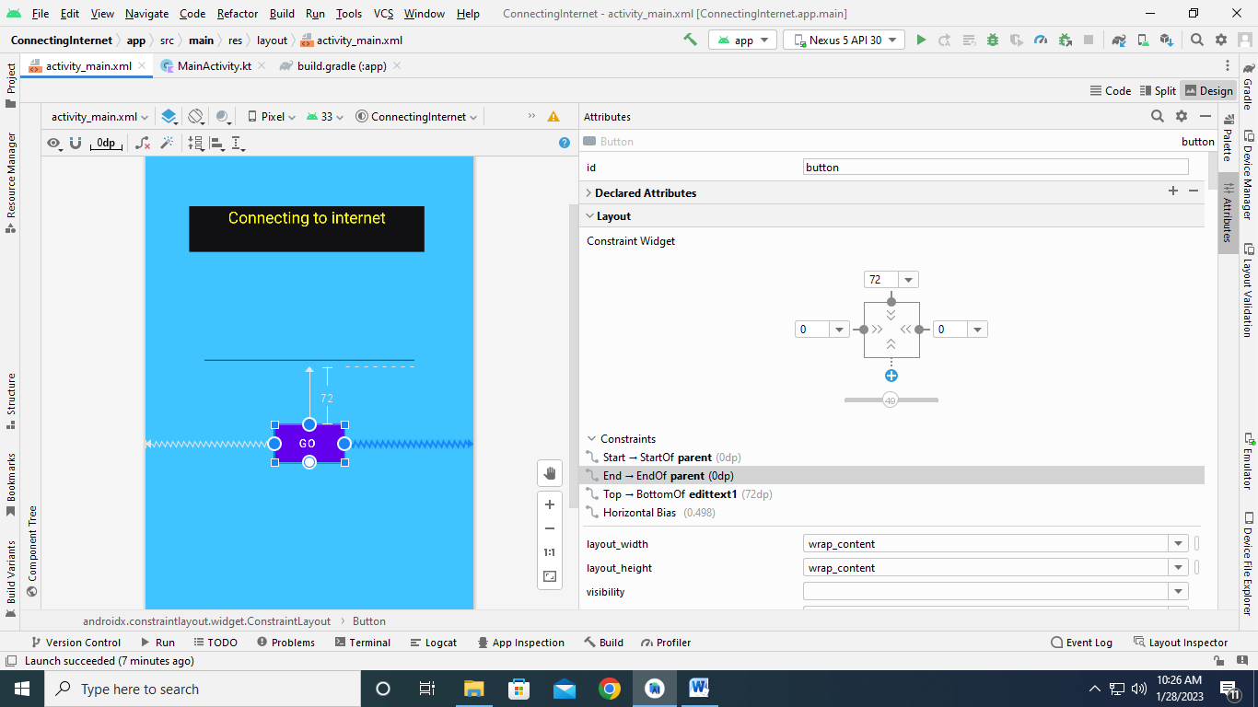

* **MainActivity code:**

**package**com.example.connectinginternet  
  
  
**import** android.annotation.SuppressLint  
**import** android.content.Intent  
**import** android.net.Uri  
**import** androidx.appcompat.app.AppCompatActivity  
**import** android.os.Bundle  
**import** android.widget.*  
  
  
**class** MainActivity : AppCompatActivity() {  
  
**override fun** onCreate(savedInstanceState: Bundle?) {  
**super**.onCreate(savedInstanceState)  
setContentView(R.layout.*activity_main*)  
**var**text1:EditText=findViewById(R.id.*edittext1*)  
**var**btn:Button=findViewById(R.id.*button*)  
btn.setOnClickListener**{  
var**str:String=**"https://"**str+=text1.*text***var**int1:Intent=Intent(Intent.*ACTION_VIEW*, Uri.parse(str))  
startActivity(int1)  
**}**}  
}

**build.graddle(app) code:**

plugins **{**id **'com.android.application'**id **'org.jetbrains.kotlin.android'  
}**android **{**namespace **'com.example.connectinginternet'**compileSdk33  
  
defaultConfig**{**applicationId**"com.example.connectinginternet"**minSdk21  
targetSdk33  
versionCode1  
versionName**"1.0"**testInstrumentationRunner**"androidx.test.runner.AndroidJUnitRunner"  
}**buildTypes**{**release **{**minifyEnabled**false**proguardFilesgetDefaultProguardFile(**'proguard-android-optimize.txt'**), **'proguard-rules.pro'  
}  
 }**compileOptions**{**sourceCompatibility JavaVersion.***VERSION_1_8***targetCompatibility JavaVersion.***VERSION_1_8*}**kotlinOptions**{**jvmTarget = **'1.8'  
}  
}**dependencies **{**implementation **'androidx.core:core-ktx:1.7.0'**implementation **'androidx.appcompat:appcompat:1.6.0'**implementation **'com.google.android.material:material:1.7.0'**implementation **'androidx.constraintlayout:constraintlayout:2.1.4'**testImplementation**'junit:junit:4.13.2'**androidTestImplementation**'androidx.test.ext:junit:1.1.5'**androidTestImplementation**'androidx.test.espresso:espresso-core:3.5.1'  
}**

**App launch:**

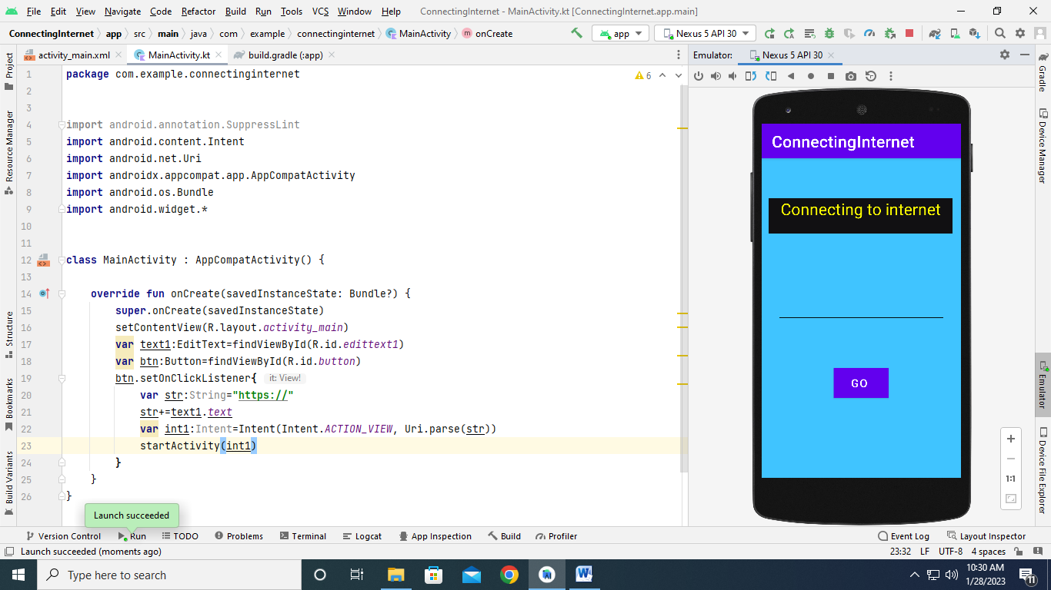

**Emulator:**



**Search in EditTextView:**

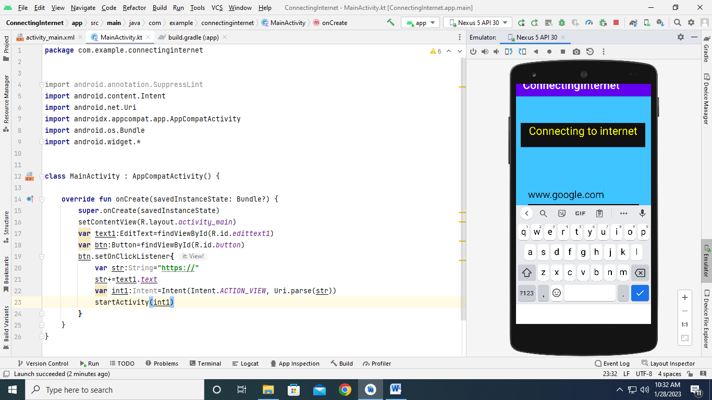

**Browser window:**

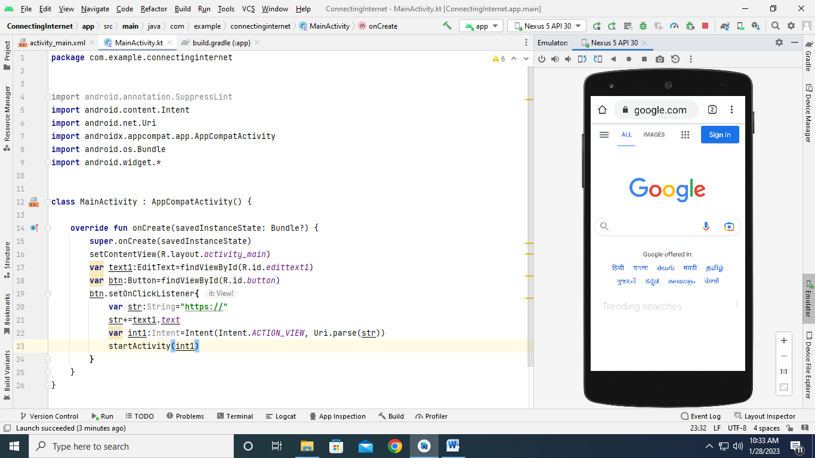

**Search** [**www.amazon.com**](http://www.amazon.com)**:**

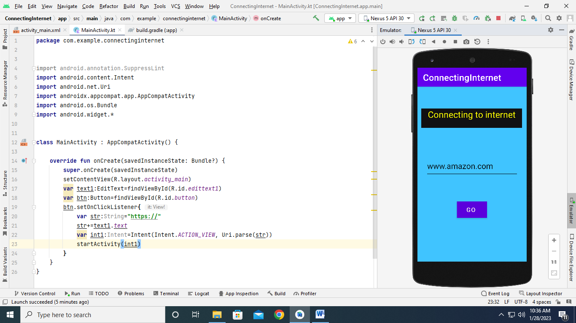

**Browser window:**

